* 1. **Introduction**

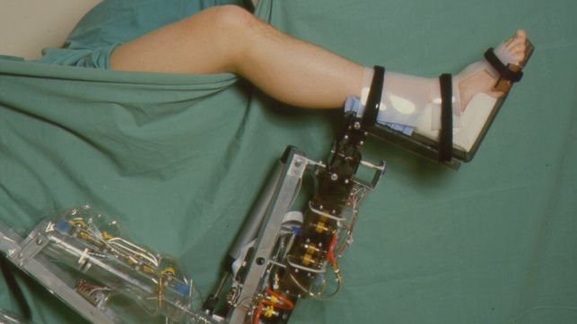

Figure 1 - Image of ARTHROBOT, one of the earliest examples of RAS in healthcare.

A consideration of the current and future capabilities of RAS technologies as applied to healthcare, with accompanying discussion of the legal, ethical, social and economic implications. Three applications of RAS in healthcare are explored, at varying stages of maturity: augmented and autonomous surgery, geriatric care robotics, and nanorobotics.

Robotics and Autonomy in Healthcare: Societal Impact of Current and Future Technologies.

The prevalence of robotic and autonomous systems (hereby RAS) within the healthcare sector has seen a rapid increase in recent decades, with the trend set to continue for the foreseeable future [1]As technologies mature, costs inevitably fall, improving availability, with demand further fuelled by changing demographics and attitudes towards automation.

Consideration of the social, ethical, legal and economic impact of this rapidly evolving sector is therefore of utmost importance; such technologies, whilst often intrinsically positive in their impact on individual health, have strong potential for disrupting social stability. Incautious adoption of such systems could yield unforeseen consequences, and so discussion must cover the potential harm, along with the proposed benefits.

Discussion here will cover areas of RAS in healthcare for which such considerations are particularly significant and numerous, though is by no means exhaustive; the direct effect of such technologies on human wellbeing calls for particular caution before fully integrating them into the healthcare sector. Current capabilities will be outlined, before exploring potential future applications, and the accompanying benefits and risks that arise.

* 1. **History of RAS in Healthcare**

Due to the strict regulation that is innate to the field of medicine, along with the potential risk to human health, adoption of RAS in healthcare has lagged behind other industries. That said, some significant contributions were made from the mid-eighties onward, forming the early steps towards the technology we see today.

1984 saw the first use of a robot to assist surgery, with the ‘Arthrobot’, developed at the University of British Colombia, providing voice controlled movement of the patient’s leg to free up the hands of the surgeon. [2]This system was utilised for over 60 successful hip surgeries.

Further experimental use continued over the next decade, with industrial robots aiding in precision tool placement, and the advent of the first truly autonomous robotic surgical tool, the ‘PROBOT’. Of particular note was the introduction of the AESOP robotic endoscope, followed seven years later by the ZEUS system, providing a combination of robotic endoscope and end effectors that is more commonly seen in modern assisted surgery These developments were precursors to the Da Vinci Surgical System, still in use today, that will be discussed further in the next section. [3]

**2.1. Augmented and Autonomous Surgery**

The role of the surgeon has always been fraught with difficulty; high psychological pressure and need for extensive technical ability forms a profession that is both difficult to enter, and to sustain. It is however in increasing demand worldwide [4], with aging populations set to increase the demand for surgeries, particularly of a routine nature.

A correlation exists between the technical difficulty of the surgical procedure, and the availability of qualified surgeons [5]; highly specialised physicians have refined their skills over decades, and their availability to patients greatly depends on their schedule of work and base of operation.

* 1. **Consideration of Current and Future Technology**

The Da Vinci Surgical System has been in worldwide operation since its FDA approval in 2000, and is designed primarily for use in minimally invasive surgery, or laparoscopy [6]. A combination of four 7DOF robotic arms control positions and orientations of both endoscope and medical instruments through a master-slave system incorporated into a nearby console. The surgeon benefits greatly in visualisation and dexterity; movement can be scaled and tremors mitigated, various safety features reduce the possibility of damage to surrounding tissue, and the surgeon’s field of view is placed in line with his instruments for a direct 3D view of the workspace.

The above features of the system were developed specifically in response to the issues that were synonymous with laparoscopy, for which the Da Vinci effectively alleviates. The difficulty of the manual procedure proves to be a barrier to the availability of the surgery for patients, thereby preventing laparoscopic surgery, and the benefits it entails, from becoming the norm. This potential reduction in surgical skill requirements provides obvious social benefits; the availability of laparoscopic surgery to patients could dramatically increase, simultaneously reducing load on the healthcare system by reducing patient recovery times.

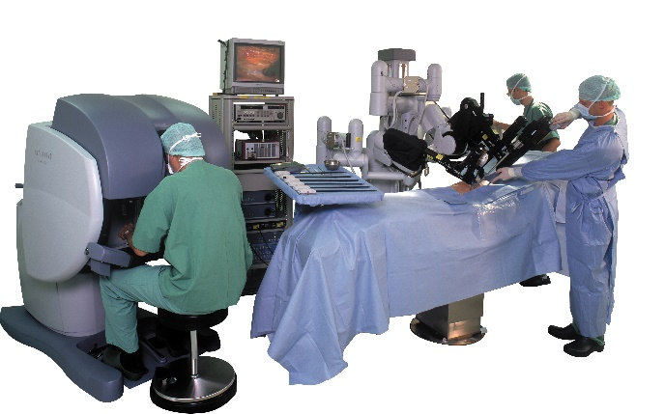

Figure 2 - Da Vinci Surgical System in Operation

Surgical systems such as the Da Vinci have further potential in the area of telesurgery; the surgeon need not be present in the operating theatre at all, but remotely operating the system from anywhere in the world. The Lindbergh Operation, carried out in 2001, successfully allowed a surgeon in New York to operate on a patient over 6000km away, using the Zeus surgical robot.[7] Having reduced signal delay to 155ms over a round trip distance of 14,000km, the operation served to prove the viability of remote surgery, albeit via a high bandwidth optical cable.

Since this landmark case, remote surgeries have been carried out with increasing frequency, and the trend is expected to continue with improvements in computing and communication technologies.

Military interest in such technologies is particularly high; development of a remote surgery system funded by DARPA grants the possibility of deploying mobile surgical stations in the field for the treatment of wounded soldiers, controlled by skilled surgeons far from the conflict zone. [8]

Thus far, haptic feedback in commercial systems has been limited. The potential benefits to the surgeon are not yet fully understood, though research into this is ongoing [9]. Haptic feedback has not proved to be an integral requirement of the surgeon, as demonstrated by the current use of surgical systems, though the possibility of substantial improvements to patient outcome is not to be ignored [10], and recent surveys by the FDA suggest that inclusion of haptics is of high desirability to surgeons. [11]

Fully autonomous surgery proves to be a difficult problem to solve, and medical professionals remain understandably sceptical regarding it’s potential. Early focus (2000 onward) centred on the automation of various tasks during surgery to reduce surgeon fatigue, with particular emphasis on suturing processes. The intelligence of these systems has seen rapid improvements. Early attempts merely followed pre-programmed processes [12], while the gradual addition of control loops serves to improve adaptability in highly variable surgical procedures. [13].

Recent advances are improving confidence in autonomous surgical systems. In 2016, the Smart Tissue Autonomous Robot carried out its first test surgery, providing a higher degree of accuracy and reliability in cutting and suturing than surgeons could provide manually. Though not fully autonomous, requiring cutting paths to be placed on the tissue, the system acts as a effective proof of concept for semi-autonomous surgery. [14]

Though these results are promising, full autonomy in surgery will likely remain elusive in the near future. Until the intelligence and adaptability of the systems dramatically increases, the complexity and variability of surgery provides a strong barrier to autonomous solutions.

The use of robotic systems (with any degree of autonomy) in surgery raises issues various issues. The Da Vinci system has been the subject of much scrutiny since its FDA approval. The cost of the equipment remains prohibitively high for many institutions, and the efficacy often questioned when compared to traditional open surgery or manual laparoscopy. [15][16] The long-term impact of such surgeries (as compared to traditional surgical methods) has also yet to be determined, and the outcome of such studies will undoubtedly influence the uptake of RAS into the surgical field. Unless the cost-benefit ratio changes, widespread implementation is unlikely.

The degradation of skills in trained professionals due to increased automation has become an important consideration in recent years, largely spurred by accidents in the aviation industry for which over reliance on autopilots was deemed the leading cause [17][18]. Huge variability and complexity in the tasks carried out by the average surgeon suggests that their role appears safe from full automation for the foreseeable future. Nevertheless, increased prevalence of robotic assistance in operating theatres could rapidly become an issue as the complexity of devices and level of involvement increases; should the role of the surgeon be relegated to one of supervision, quality of response in the event of a system failure will inevitably suffer. [19] This leads to consideration of a balance that must be met; If overall patient outcome statistically improves with further automation, do we just accept that individual surgery outcome in the event of a system failure could dramatically reduce?

The possibility of system failures highlights another contentious issue; should a procedure go wrong, where does the burden of responsibility lie? Various lawsuits have been filed against Intuitive Surgical, the producers of the Da Vinci system [20], implicating the device in failures leading to death and disfigurement. Reasons cited range from equipment failures at critical moments, to steep learning curves and insufficient surgeon training. Often it is unclear where responsibility lies, with the surgeon, the hospital, the administration, and the company itself often coming under fire. [21] It is likely that many legal precedents will be set in the coming years, as the legal system adjusts to an uptake of tools of increasing complexity and varying degrees of automation.

The technology developed within this sector has wider applications. Remote operation has been a source of issues for unmanned space and undersea vehicles [22], and developments in communications and haptics will undoubtedly improve the efficacy of any remotely operated systems.

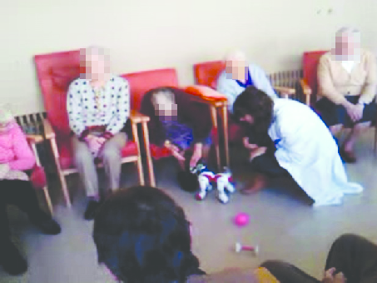

Figure 3 - AIBO during acceptance testing with dementia patients.

**3.1. RAS in Geriatric Care.**

As life expectancy increases worldwide, changing age demographics present us with a significant problem; who, or what, is going to care for us in old age? The problem is not a trivial one, and unless occupation demographics shift significantly to match this new demand for care workers, RAS may prove to a saving grace.

This issue has prompted a wealth of new research in RAS, in fields such as (but not limited to) computer vision, artificial intelligence, soft robotics, HRI and robot ethics. Japanese investment into the field has increased dramatically in response to their somewhat unique elderly population problem; 26% of the population are now over the age of 65 [23]. The care profession is particularly relationship driven however, with care workers filling a social role that extends beyond their basic duties. Could robots ever provide a suitable substitution, and if so, would it be ethical? The robot ethics sphere has been a hotbed for discussion on this topic but is far from any consensus.

**3.2. Consideration of Current and Future Technologies**

The breadth of tasks involved in the support and monitoring of the elderly has given rise to incredibly varied applications of RAS, largely still in the research and development phase. Such solutions in development include: RoBear, an anthropomorphic device for lifting patients between beds and chairs [24]. AIBO, a companion robot aiming to aid in the rehabilitation of severe dementia patients [25]; and MiRo, a dog robot combined with home embedded sensors designed to provide close monitoring of the infirm [26]. Such examples provide only a small glimpse of current research, but highlights both the social and technical problems presented to researchers.

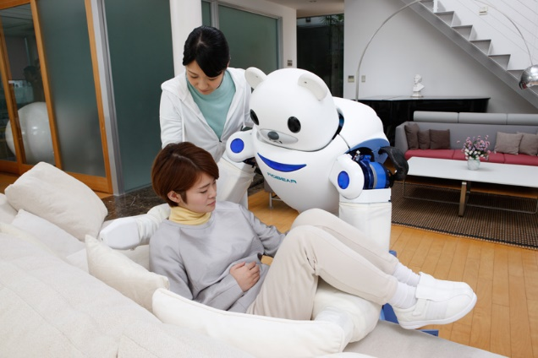

Figure 4 - RoBear performing lifting procedures.

Advancements in various fields are set to change care robotics dramatically. Computer vision and machine learning improvements will greatly improve the situational awareness of care robots, allowing them the traverse highly variable home environments. Benefits here also apply to object recognition, vastly improving the fetching capabilities of robotic assistants. Soft robotics researchers aim to improve the HRI aspect by creating robots that can actively engage in direct contact with patients and objects without risk of harm or damage. Complexity of social AI systems could greatly alleviate issues with loneliness that are so prevalent amongst the live-alone elderly, while simultaneously improving the robots capability to understand intention and context.

There are significant concerns regarding the uptake of robotics in care roles however. Ethically, we run into new territory regarding the interaction of the elderly with intelligent systems; Regardless of how complex the system becomes, perhaps even allowing full fluid conversations between human and machine, is it simply a form of deception? When considering this problem, it is worth interrogating individual personal beliefs – would anyone feel comfortable knowing that the entity they are building a relationship with is completely devoid of empathy and emotion? The likely answer is no. Thus, by extension, it could be suggested that the use of intelligent systems in replicating the social benefits granted by human presence is inherently unethical, a view termed ‘the deception objection’ [27]. This is particularly true for the generations first subject to the use of such systems, for whom the illusion of genuine human affection may be completely convincing.

Moreover, the lack of care workers may not remain such an issue. Automation in other sectors will likely begin to shift occupational demographics; huge sectors of the work force are prime candidates for replacement by automation, with unskilled labourers and logistics workers expected to be hit hard within the next decade. A 2013 report by the University of Oxford considering the likelihood of automation in various sectors deemed care work (of various types) to be amongst the least susceptible to automation [28]. This may suggest, assuming the labour force is malleable enough, that we will see an increase in numbers within geriatric care occupations, thereby reducing the requirement for increased RAS in the sector.

**4.1. Nanorobotics in Medicine**

Widely considered a powerful emerging technology, nanorobotics seems set to cause a paradigm shift in human capability as its potential is fully realised and investment ramps up. The prospective applications are numerous across all human endeavours, and the medical field is no exception.

Inspiration for nanorobotics is in plentiful supply; biological systems utilise nanomachinery of astounding complexity, at scale and level of organisation that puts even our most complex logistical systems to shame.

Biology contains a huge variation of such nanomachinery: Kinesin and dynein proteins ‘walk’ along the support structures of the cell, transporting materials; helicase and polymerase unzip and rebuild DNA, providing the replication capabilities so common to life; and flagellum on bacterial cells utilise rotary motors to propel the cell towards or away from stimuli.

These examples provide only a small glimpse of the capabilities of nanoscale machinery, and though the artificial synthesis of such systems is a profoundly difficult problem, the feasibility of using nanoscale machines for complex tasks is readily demonstrated by our continued existence.

**4.2. Consideration of Current and Future Technologies in Nanorobotics**

Nanorobotics technology is still in its infancy, and current implementation is largely limited to the use of nanoparticles for improved cancer cell detection and drug delivery. Current applications of nanotech in drug delivery have allowed for sustained or triggered drug delivery, [29] prolonged drug half-life and improved drug distribution characteristics. Targeted drug delivery, considered to be the next generation of nanotechnology in medicine, has proven an effective way to reduce the side effects of therapeutic drugs, whilst improving the efficacy. [30]

It is here that implementation of some degree of autonomy has begun, with the target and function effectively pre-programmed by the structure of the nanoparticle synthesised.

Arguably these current applications are lacking in an aspect often considered integral to the field RAS; the ability to react to external stimuli and change its behaviour accordingly. A convergence of research NEMS (nano electromechanical systems) and information processing and management is bringing with it the possibility of nanoscale medical devices. [31] Such devices could allow for autonomous drug delivery, sensitive to changing conditions inside the body, along with detailed external monitoring of internal bodily functions.

Improved tissue repair has also been cited as a potential application; nanorobots attaching themselves to white blood cells will naturally be carried to any site of injury or inflammation, where material can be deposited to aid in rapid recovery or prevent further blood loss. [32]

The economic impact of such technologies should not be underestimated. Current therapies for a range of ailments often take a brute force approach, leading to a wide range of side effects, reduced recovery time, and higher strain on the healthcare system. This issue is particularly prevalent in many current cancer treatment methods, for which costs are extremely high, and patient comfort poor. Development of nanorobotic solutions capable of targeting only the offending cancerous cells could greatly reduce patient suffering and overall economic cost, whilst vastly improving efficacy of treatment. [33]

Benefits aside, the potential for harm of such technology mustn’t be ignored. Nanorobotic systems could provide an extremely efficient delivery method for any desired payload, opening up the potential for highly effective toxin delivery methods. Toxins could be administered in a manner that replicates the symptoms of disease, potentially providing a means of untraceable assassination. Toxin release could potentially be mediated by the presence of specific genetic sequences, thereby providing a means of selectively targeting ethnic groups.

Barriers to such implementations do of course exist; the intrinsic technical difficulty of developing the technology is not trivial, and the cost prohibitively high. Military spending on nanotech research worldwide remains high however, with medical research into nanorobotics providing ample material for military applications, and thus worries over a nanotechnology arms race are not unfounded. [34] Should the cost of such technologies dramatically reduce, strict control of usage may become difficult, putting dangerous technology in the hands of anyone willing to use it.

**5.1. Wider Considerations of RAS in Healthcare.**

Life expectancy worldwide is at a high, and continuing to rise, raising important questions regarding the demographics of our societies. The UK over 65 population has been steadily rising [35], and though the exact contribution due to improved medical technology is not fully understood, it is widely accepted that its role is significant [36]. In the short term, the obvious implication is increased strain on the healthcare system, with an increased demand for care workers and close monitoring of the elderly. Incidence of obesity and dementia is set to rise, and the changing family structures may increase the prevalence of care centres for the elderly [37]. Though RAS implementation in the care sector is increasing, the issues surrounding social interaction discussed previously may not be overcome.

Long term speculation on increased lifespan leads to some interesting considerations. Should the projected capabilities of various health technologies come to fruition (particularly in nanotech, where the potential for sustained monitoring and repair of bodily systems is high), life expectancy could continue to rise dramatically, taking us far beyond the natural human lifespan.

This outcome is undoubtedly appealing to many, but the resulting societal changes would monumental, and likely followed by huge economic, social and political upheaval. Family structures could dramatically change, with no guarantee that our the currently accepted views on lifetime partnership and parenthood would emerge unscathed.

World population issues could be drastically exacerbated, with birth rates far exceeding death rates. Without consideration of the implications, there is a high probability for conflict over resources and land, particularly when combined with imminent issues regarding climate.

A particularly worrying and relevant issue arises surrounding inequality; as of 2016, the top 1% of population held more wealth in currency and assets than the rest of the world combined, even as levels of poverty decreased. [38] This raises important considerations regarding the distribution of health technology. If the most extensive benefits are only reaped by the wealthy, we could begin to see a completely new form of inequality arise. No longer would the wealthy benefit from the edge afforded by increased resources alone, but also those granted by improved health and lifespan.

This may not be limited to the wealthiest; quality and length of life in countries with access to new technologies may far outstrip that of less developed nations. Racial discrimination is still a prevalent issue, predicated on the assumption that different ethnic groups fit within a value hierarchy. It is worrying to consider how the drastic differences in physicality afforded by increased health and lifespan may further fuel such ideology.

Monitoring within various aspects of healthcare has the potential to greatly benefit the individual: Nanorobotic monitoring of internal bodily function could alert us of health issues early, or track diet and fitness over time; Care robots could track our movements and actions, learning how we use our homes and alerting the authorities at the first sign of trouble; and surgical robots could learn from the surgeon, and provide data that helps the system learn to operate with increased autonomy.

These examples all involve the gathering and interpretation of data, and under current legislation, it is often unclear where said data will end up, suggesting a potential for collected data to be misused. Though a patient may agree to have their internal bodily functions monitored by nanorobots for the sake of their health, there is no guarantee that the collected data will be used for that purpose alone, in present or future circumstances.

The ramifications of this vary in severity; targeted advertising based on your level of fitness or mood could be construed as a minor inconvenience, but strict tax regulation based on eating habits and substance abuse would likely be considered a huge violation of privacy.

**6.1. Conclusions**

Of the healthcare fields considered, the potential quality of life improvements are plain to see, with promises of reduced suffering, lower economic strain, and longer, happier lives providing ample reason for celebration.

It is important however, that a consistent consideration of the full impact of new technologies is considered; too often the proponents of radical new technologies are blinded by the short-term benefits on offer, without consideration of the wider context.

Arguably, the power granted by each new technological breakthrough is continuing to increase, making close analysis of consequence a major priority moving forward.

**Bibliography**

[1]Shimon Y. Nof, Springer Handbook of Automation**,** Springer Science & Business Media, 16 Jul 2009

[2] Dong-Soo Kwon *et al*., *ARTHROBOT : a new surgical robot system for total hip arthroplasty*. Proceedings 2001 IEEE/RSJ International Conference on Intelligent Robots and Systems. Expanding the Societal Role of Robotics in the the Next Millennium *(Cat. No.01CH37180)*, Maui, HI, 2001, pp. 1123-1128 vol.2.

[3] Robotic Surgery -*A Review on Recent advances in Surgical Robotic Systems*

[4] Bureau of Labor Statistics, U.S. Department of Labor, *Occupational Outlook Handbook*, Physicians and Surgeons, found at https://www.bls.gov/ooh/healthcare/physicians-and-surgeons.htm (visited *January 25, 2018*).

[5] Spaliviero, M. Eastham, J.A. *Relationship between surgical volume and patient outcomes*, Trends in Urology & Men's HealthVolume 6, Issue 2

[6] Intuitive Surgical, History, found at https://www.intuitivesurgical.com/company/history (visited January 26 2018)

[7] Marescaux, J et al. *Transcontinental Robot-Assisted Remote Telesurgery: Feasibility and Potential Applications*, Ann Surg. 2002 Apr; 235(4): 487–492

[8] Martini, G. *Glimpses of future battlefield medicine – the proliferation of robotic surgeons and unmanned vehicles and technologies*,  Volume 22 No. 3

[9] E. P. Westebring – van der Putten, R. H. M. Goossens, J. J. Jakimowicz & J. Dankelman*, Haptics in minimally invasive surgery – a review*, Minimally Invasive Therapy & Allied Technologies Vol. 17, Iss. 1, 2008

[10] N. Enayati, E. De Momi and G. Ferrigno, *Haptics in Robot-Assisted Surgery: Challenges and Benefits*. IEEE Reviews in Biomedical Engineering, vol. 9, pp. 49-65, 2016

[11] Federal Drug Administration (2012). *Small Sample Survey – Final Report Topic: da Vinci Surgical System* . Silver Spring: MedSun, p.1.

[12] Kang H, Wen JT. *EndoBot: a robotic assistant in minimally invasive surgeries*. IEEE International Conference on Robotics and Automation, (ICRA), vol 2, 2001; 2031–2036.

[13] Bauernschmitt R,Schirmbeck EU, Knoll A, et al. *Towards robotic heart surgery: introduction of autonomous procedures into an experimental surgical telemanipulator system*. Int J Med Robot2005; **1**(3): 74–79.

[14] Shademan, A et al. *Supervised autonomous robotic soft tissue surgery,* science translational medicine*,* 04 may 2016

[15] J. Yu, Y. Wang, Y. Li, X. Li, C. Li, J. Shen, *The safety and effectiveness of Da Vinci surgical system compared with open surgery and laparoscopic surgery: a rapid assessment*, Journal of Evidence-Based Medicine, volume 7, issue 2 May 2014, pages 121–134

[16] Wright JD, Ananth CV, Lewin SN, Burke WM, Lu Y, Neugut AI, Herzog TJ, Hershman DL. *Robotically Assisted vs Laparoscopic Hysterectomy Among Women With Benign Gynecologic Disease*. *JAMA,* 2013, pages 689–69

[17] Noyes, J. (2007). *Decision Making in Complex Environments.* Aldershot, UK: Ashgate, 74

[18] Ebbatson, M. (2009). *The Loss of Manual Flying Skills in Pilots of Highly Automated Airliners.* [PhD thesis] Cranfield University School of Engineering , Cranfield.

[19] Volz, K et al. *An Evaluation of Cognitive Skill Degradation in Information Automation.*

Proceedings of the Human Factors and Ergonomics Society Annual Meeting

Vol 60, Issue 1, pp. 191 – 195

[20] Drugwatch, (2017). *Da Vinci Robot Surgery Lawsuits.* [online] Available at https://www.drugwatch.com/davinci-surgery/lawsuits/ [accessed 27/01/18]

[21] Federal Drug Administration (2012). *Small Sample Survey – Final Report Topic: da Vinci Surgical System* . Silver Spring: MedSun, p.1.

[22] M. Stelzer, B. M. Steinmetz, P. Birkenkampf, J. Vogel, B. Brunner and S. Kühne, *Software architecture and design of the Kontur-2 mission*, 2017 IEEE Aerospace Conference, Big Sky, MT, 2017, pp. 1-17.

[23] Statistics Japan, (2017). Japan Statistical Yearbook 2017. [online] Available at: http://www.stat.go.jp/english/data/nenkan/67nenkan/index.htm [Accessed 29/01/18

[24] Riken, (2015). *The Strong Robot With a Gentle Touch.* [online] Available at http://www.riken.jp/en/pr/press/2015/20150223_2/ [accessed 29/01/18]

[25] Journal of Gerontology: medical sciences, 2004, Vol. 59A, No. 1, 83–8

[26] University of Sheffield, (2016). *University spin-out company with Sebastian Conran to develop next generation of robots.* [online] Available at https://www.sheffield.ac.uk/news/nr/university-spin-out-company-with-sebastian-conran-to-develop-next-generation-of-robots-1.576135 [accessed 28/01/18]

[27] Coeckelbergh, M. *Are Emotional Robots Deceptive?*, IEEE Transactions on Affective Computing ( Volume: 3, Issue: 4, Fourth Quarter 2012

[28] Carl Benedikt Frey† and Michael A. Osborne, *The future of employment: how susceptible are jobs to computerisation?*, Oxford Martin Programme on Technology & Employment September 17, 2013.

[29] Shi J, Votruba AR, Farokhzad OC, Langer R. *Nanotechnology in Drug Delivery and Tissue Engineering: From Discovery to Applications.* Nano letters. 2010; 10:3223–3230

[30] Shi J, Votruba AR, Farokhzad OC, Langer R. *Nanotechnology in Drug Delivery and Tissue Engineering: From Discovery to Applications*. Nano letters. 2010; 10:3223–3230

[31] Staples, M., Daniel, K., Cima, M.J. et al. *Application of Micro- and Nano-Electromechanical Devices to Drug Delivery.* Pharm Res (2006) 23: 847.

[32] Casal, A et al. (2018). *Nanorobots As Cellular Assistants in Inflammatory Responses.*

[33] M. Venkatesan and B. Jolad, *Nanorobots in cancer treatment.* *INTERACT-2010*, Chennai, 2010, pp. 258-264.

[34] Altmann, J. *Military Uses of Nanotechnology: Perspectives and Concerns*. *Security Dialogue*. Vol 35, Issue 1, pp. 61 – 79

[35] Office for National Statistics, (2017). *Overview of the UK Population: March 2017*. [online] Available at https://www.ons.gov.uk/peoplepopulationandcommunity/populationandmigration/populationestimates/articles/overviewoftheukpopulation/mar2017 [accessed 25/01/28]

[36] Mathers, Colin D et al. *Causes of international increases in older age life expectancy.* The Lancet , Volume 385 , Issue 9967 , 540 – 548

[37] American Hospital Association. *When I'm 64: How Boomers Will Change Health Care.* Chicago, IL; 2007.

[38] Credit Suisse, (2017). *Global Wealth Report 2017* [online] Available at https://www.credit-suisse.com/corporate/en/research/research-institute/global-wealth-report.html [accessed 28/01/18]